# Program 1: First Come First Serve (FCFS)

#include <iostream> using namespace std; #define max 10

int main()

{

int n,p[max],bt[max],ct[max],wt[max],tt[max]; float tawt=0,tatt=0,awt=0,att=0;

cout<< "Enter number of processes :"; cin>>n;

cout<< "Enter process number and burst time :"; for(int i=1;i<=n;i++)

{

cin>>p[i]>>bt[i];

}

ct[1]=bt[1];

for(int i=2;i<=n;i++)

{

ct[i]=ct[i-1]+bt[i];

}

for(int i=1;i<=n;i++)

{

wt[i]=ct[i]-bt[i];

tt[i]=wt[i]+bt[i];

}

for(int i=1;i<=n;i++)

{

tawt=tawt+wt[i]; tatt=tatt+tt[i];

}

awt=tawt/n; att=tatt/n;

cout<<"Process\t\tBT\t\tCT\t\tWT\t\tTT"<<endl; for(int i=1;i<=n;i++)

{

cout<<"P"<<p[i]<<"\t\t"<<bt[i]<<"\t\t"<<ct[i]<<"\t\t"<<wt[i]<<"\t\t"<<tt[i]<<endl;

}

cout<<"Average Waiting Time :"<<awt<<endl; cout<<"Average Turnaround Time :"<<att<<endl;

}

# Output:

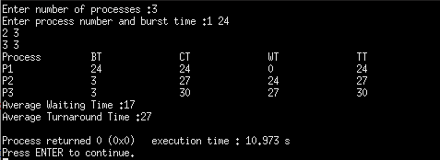

**Program 2: First Come First Serve with arrival time(FCFS)**

#include <iostream> using namespace std; #define max 10

int main()

{

int n,p[max],bt[max],ct[max],wt[max],tt[max],at[max]; float tawt=0,tatt=0,awt=0,att=0;

cout<< "Enter number of processes :"; cin>>n;

cout<< "Enter process number,burst time and arrival :"; for(int i=1;i<=n;i++)

{

cin>>p[i]>>bt[i]>>at[i];

}

//sorting

for(int i=1;i<=n;i++)

{

for(int j=1;j<=n;j++)

{

if(at[i]<at[j])

{

int t1,t2,t3;

t1=at[i]; at[i]=at[j]; at[j]=t1;

t2=p[i]; p[i]=p[j]; p[j]=t2;

t3=bt[i]; bt[i]=bt[j]; bt[j]=t3;

}

}

}

ct[1]=bt[1];

for(int i=2;i<=n;i++)

{

ct[i]=ct[i-1]+bt[i];

}

for(int i=1;i<=n;i++)

{

wt[i]=ct[i]-bt[i]-at[i]; tt[i]=wt[i]+bt[i];

}

for(int i=1;i<=n;i++)

{

tawt=tawt+wt[i]; tatt=tatt+tt[i];

}

awt=tawt/n; att=tatt/n;

cout<<"Process\t\tBT\t\tAT\t\tCT\t\tWT\tTT"<<endl; for(int i=1;i<=n;i++)

{

cout<<"P"<<p[i]<<"\t\t"<<bt[i]<<"\t\t"<<at[i]<<"\t\t"<<ct[i]<<"\t\t"<<wt[i]<

<"\t"<<tt[i]<<endl;

}

}

# Output:

cout<<"Average Waiting Time :"<<awt<<endl; cout<<"Average Turnaround Time :"<<att<<endl;

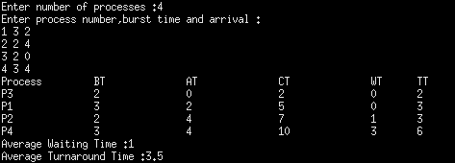

# Program 3: Shortest Job First (SJF)

#include <iostream> using namespace std; #define max 10

int main()

{

int n,p[max],bt[max],ct[max],wt[max],tt[max]; float tawt=0,tatt=0,awt=0,att=0;

cout<< "Enter number of processes :"; cin>>n;

cout<< "Enter process number and burst time :"; for(int i=1;i<=n;i++)

{

cin>>p[i]>>bt[i];

}

//sorting

for(int i=1;i<=n;i++)

{

for(int j=1;j<=n;j++)

{

if(bt[i]<bt[j])

{

int t1,t2;

t1=bt[i]; bt[i]=bt[j]; bt[j]=t1;

t2=p[i]; p[i]=p[j]; p[j]=t2;

}

}

}

ct[1]=bt[1];

for(int i=2;i<=n;i++)

{

ct[i]=ct[i-1]+bt[i];

}

for(int i=1;i<=n;i++)

{

wt[i]=ct[i]-bt[i];

tt[i]=wt[i]+bt[i];

}

for(int i=1;i<=n;i++)

{

tawt=tawt+wt[i]; tatt=tatt+tt[i];

}

awt=tawt/n; att=tatt/n;

cout<<"Process\t\tBT\t\tCT\t\tWT\t\tTT"<<endl; for(int i=1;i<=n;i++)

{

cout<<"P"<<p[i]<<"\t\t"<<bt[i]<<"\t\t"<<ct[i]<<"\t\t"<<wt[i]<<"\t\t"<<tt[i]<<endl;

}

}

# Output:

cout<<"Average Waiting Time :"<<awt<<endl; cout<<"Average Turnaround Time :"<<att<<endl;

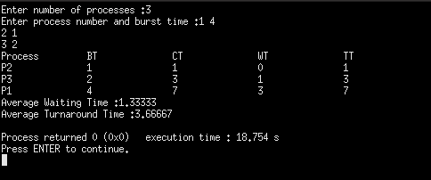

# Program 4 : Priority with Non Preemptive

#include <iostream> using namespace std; #define max 10

int main()

{

int n,p[max],bt[max],ct[max],wt[max],tt[max],priority[max]; float tawt=0,tatt=0,awt=0,att=0;

cout<< "Enter number of processes :"; cin>>n;

cout<< "Enter process number,burst time and priority :"; for(int i=1;i<=n;i++)

{

cin>>p[i]>>bt[i]>>priority[i];

}

for(int i=1;i<=n;i++)

{

for(int j=1;j<=n;j++)

{

if(priority[i]<priority[j])

{

int t1,t2,t3; t1=priority[i]; priority[i]=priority[j];

priority[j]=t1;

t2=p[i]; p[i]=p[j]; p[j]=t2;

t3=bt[i]; bt[i]=bt[j]; bt[j]=t3;

}

}

}

ct[1]=bt[1];

for(int i=2;i<=n;i++)

{

ct[i]=ct[i-1]+bt[i];

}

for(int i=1;i<=n;i++)

{

wt[i]=ct[i]-bt[i];

tt[i]=wt[i]+bt[i];

}

for(int i=1;i<=n;i++)

{

tawt=tawt+wt[i]; tatt=tatt+tt[i];

}

awt=tawt/n; att=tatt/n;

cout<<"Process\tBT\tPriority\tCT\tWT\tTT"<<endl; for(int i=1;i<=n;i++)

{

cout<<"P"<<p[i]<<"\t"<<bt[i]<<"\t"<<priority[i]<<"\t\t"<<ct[i]<<"\t"<<wt[i]<<"\t"<

<tt[i]<<endl;

}

}

# Output:

cout<<"Average Waiting Time :"<<awt<<endl; cout<<"Average Turnaround Time :"<<att<<endl;

# Program 5: Shortest Job First (SJF) with arrival time

#include <iostream> using namespace std; #define max 10

int main()

{

int n,p[max],bt[max],ct[max],wt[max],tt[max],at[max],min=0,k=1,sum=0; float tawt=0,tatt=0,awt=0,att=0;

cout<< "Enter number of processes :"; cin>>n;

cout<< "Enter process number, burst time and arrival time :"; for(int i=1;i<=n;i++)

{

cin>>p[i]>>bt[i]>>at[i];

}

//sorting...

for(int i=1;i<=n;i++)

{

for(int j=1;j<=n;j++)

{

if(at[i]<at[j])

{

int t1,t2,t3;

t1=at[i]; at[i]=at[j]; at[j]=t1;

t2=p[i]; p[i]=p[j]; p[j]=t2;

t3=bt[i]; bt[i]=bt[j]; bt[j]=t3;

}

}

}

bt[0]=0;

for(int i=1;i<=n;i++)

{

sum=sum + bt[i-1]; min=bt[k];

for(int j=k;j<=n;j++)

{

if( sum >= at[j] && bt[j] <= min)

{

int t1,t2,t3;

t1=at[i]; at[i]=at[j];

at[j]=t1;

t2=p[i]; p[i]=p[j]; p[j]=t2;

}

k++;

}

t3=bt[i]; bt[i]=bt[j]; bt[j]=t3;

}

ct[1]=bt[1]; wt[1]=ct[1]-bt[1]-at[1]; tt[1]=wt[1]+bt[1];

for(int i=2;i<=n;i++)

{

ct[i]=ct[i-1]+bt[i];

}

for(int i=1;i<=n;i++)

{

wt[i]=ct[i]-bt[i]-at[i]; tt[i]=wt[i]+bt[i];

}

for(int i=1;i<=n;i++)

{

tawt=tawt+wt[i]; tatt=tatt+tt[i];

}

awt=tawt/n; att=tatt/n;

cout<<"Process\t\tBT\t\tAT\t\tCT\t\tWT\t\tTT"<<endl; for(int i=1;i<=n;i++)

{

cout<<"P"<<p[i]<<"\t\t"<<bt[i]<<"\t\t"<<at[i]<<"\t\t"<<ct[i]<<"\t\t"<<wt[i]<<"\t\t"<

<tt[i]<<endl;

}

cout<<"Average Waiting Time :"<<awt<<endl;

cout<<"Average Turnaround Time :"<<att<<endl;

}

# Output:

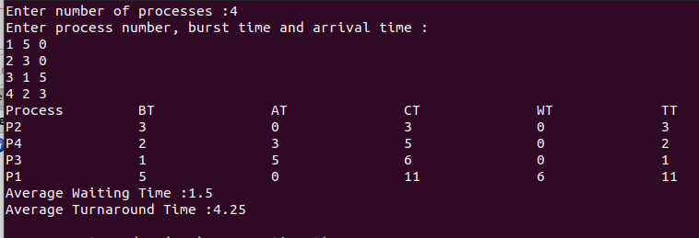

**Program 6 : Priority with Non Preemptive with arrival time**

#include <iostream> using namespace std; #define max 10

int main()

{

int n,p[max],bt[max],ct[max],wt[max],tt[max],at[max],priority[max],min=0,k=1,sum=0;

float tawt=0,tatt=0,awt=0,att=0;

cout<< "Enter number of processes :"; cin>>n;

cout<< "Enter process number, burst time, arrival time and priority :"; for(int i=1;i<=n;i++)

{

cin>>p[i]>>bt[i]>>at[i]>>priority[i];

}

//sorting

for(int i=1;i<=n;i++)

{

for(int j=1;j<=n;j++)

{

if(at[i]<at[j])

{

int t1,t2,t3,t4; t1=at[i]; at[i]=at[j]; at[j]=t1;

t2=p[i]; p[i]=p[j]; p[j]=t2;

t3=bt[i]; bt[i]=bt[j]; bt[j]=t3;

t4=priority[i]; priority[i]=priority[j]; priority[j]=t4;

}

}

} bt[0]=0;

for(int i=1;i<=n;i++)

{

sum=sum + priority[i-1]; min=priority[k];

for(int j=k;j<=n;j++)

{

if( sum >= at[j] && priority[j] <= min)

{

int t1,t2,t3,t4;

t1=at[i]; at[i]=at[j]; at[j]=t1;

t2=p[i]; p[i]=p[j]; p[j]=t2;

t3=bt[i]; bt[i]=bt[j]; bt[j]=t3;

t4=priority[i]; priority[i]=priority[j];

priority[j]=t4;

}

} k++;

}

ct[1]=bt[1]; wt[1]=ct[1]-bt[1]-at[1]; tt[1]=wt[1]+bt[1];

for(int i=2;i<=n;i++)

{

ct[i]=ct[i-1]+bt[i];

}

for(int i=1;i<=n;i++)

{

wt[i]=ct[i]-bt[i]-at[i]; tt[i]=wt[i]+bt[i];

}

for(int i=1;i<=n;i++)

{

tawt=tawt+wt[i]; tatt=tatt+tt[i];

}

awt=tawt/n; att=tatt/n;

cout<<"Process\t\tBT\t\tAT\t\tCT\t\tWT\t\tTT"<<endl; for(int i=1;i<=n;i++)

{

cout<<"P"<<p[i]<<"\t\t"<<bt[i]<<"\t\t"<<at[i]<<"\t\t"<<ct[i]<<"\t\t"<<wt[i]<<"\t\t"<<tt[i]<< endl;

}

# Output :

}

cout<<"Average Waiting Time :"<<awt<<endl; cout<<"Average Turnaround Time :"<<att<<endl;

